Steps to install the drivers for USB to RS-232 converter:
Step1
Insert the installation CD included with Atmega16/32 development into your CD drive
Step2
Copy “\Drivers\CDM2.02.04WHQLCertified” folder from the installation CD.
Step3
Connect the one end of the USB cable to your PC and the other end to the USB Wireless module.
Step4
Windows will open a Found New Hardware Wizard window. Select No, not this time radio button and click Next.
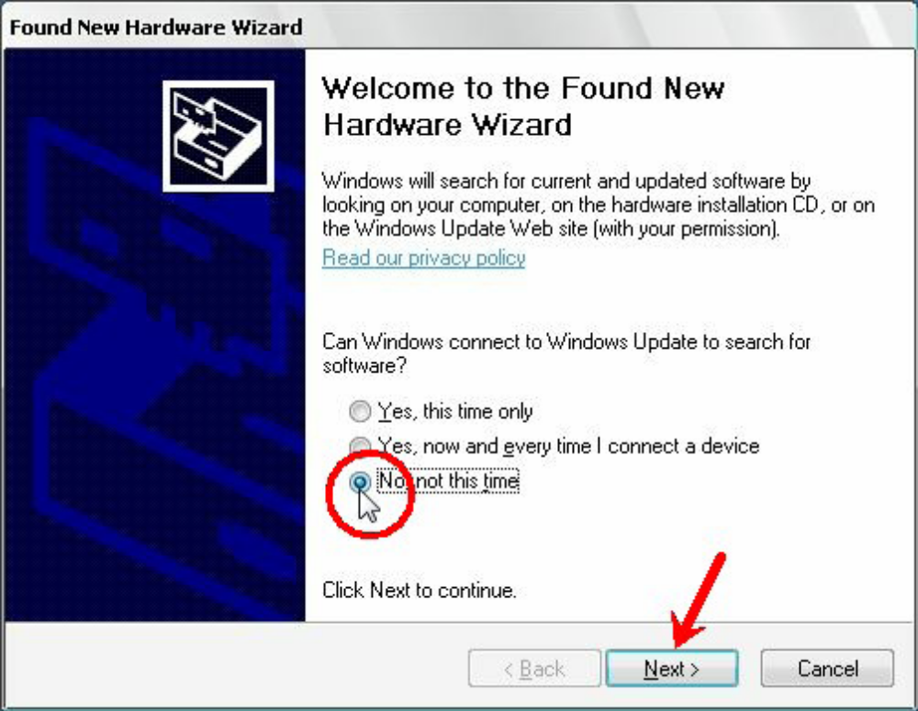
In the next window that appears select the second option to install the drivers manually by specifying the driver location.
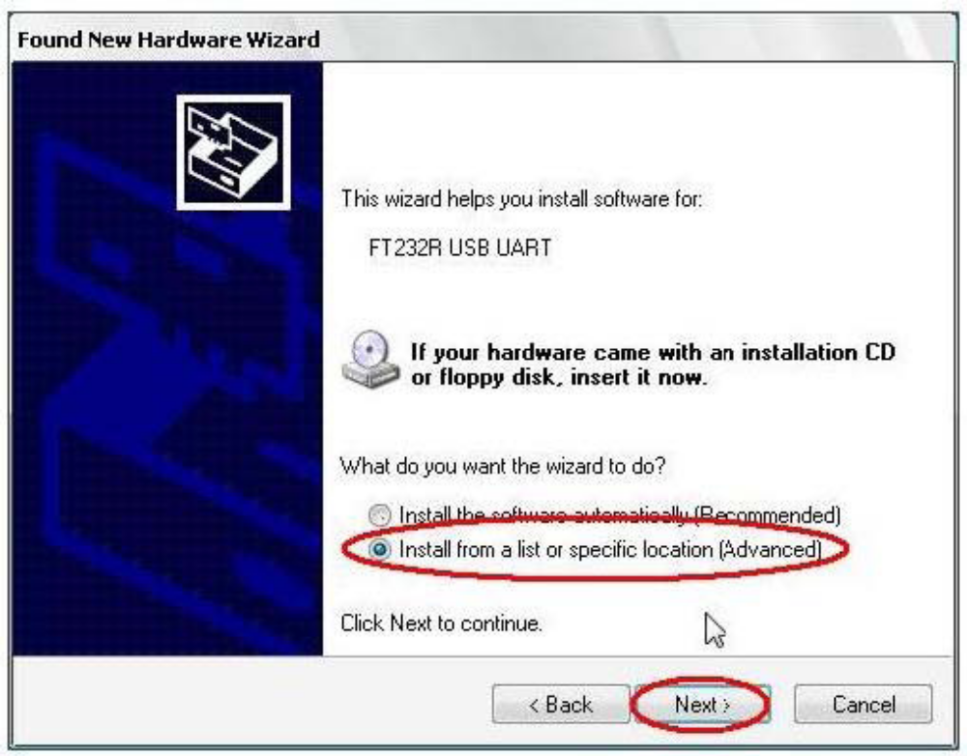
Step6
In the following window select the highlighted checkbox and click on browse to specify the driver location. The drivers are located in \Drivers\CDM 2.02.04 WHQL Certified\i386 folder.
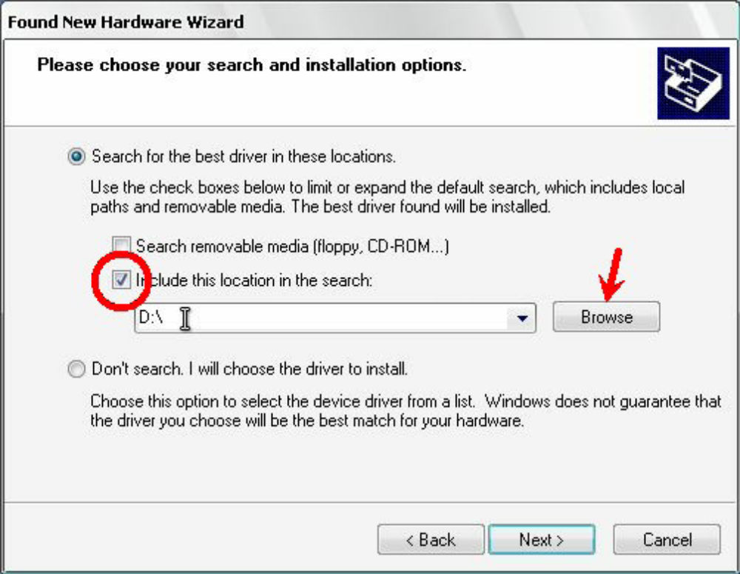
Click next to begin the driver installation.
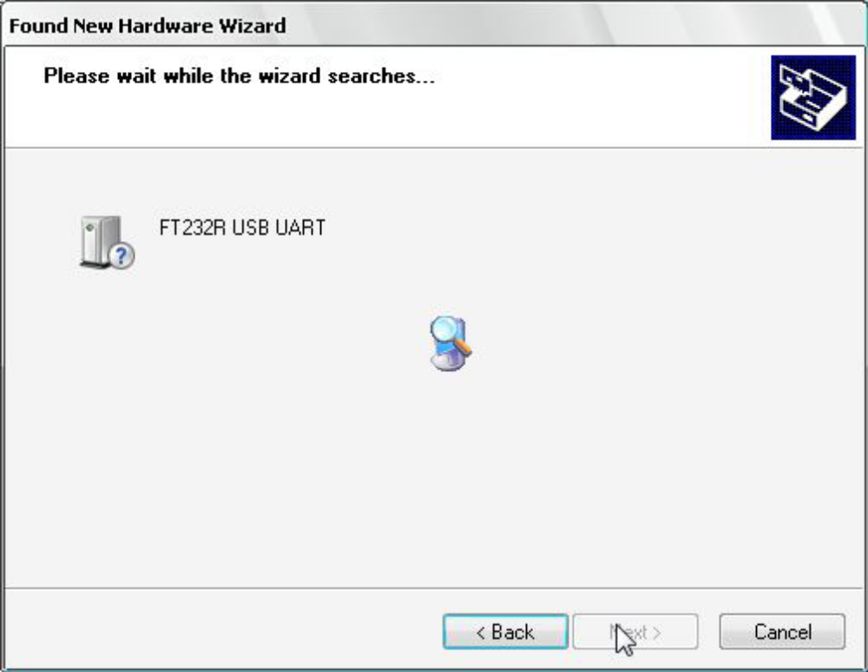
Step8
On successfully installing the drivers following window will appear. Click Finish to complete the installation.
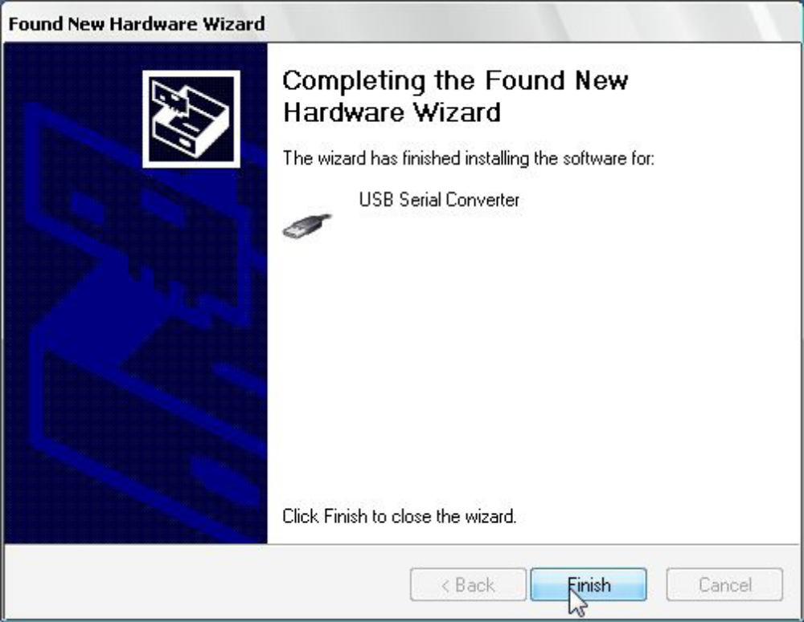
After installation of FT232 USB UART driver windows will ask for Serial Port Driver. The driver installation procedure is same as procedure FT232 USB UART.
Identifying Comport number
To use terminal.exe or any other serial control program we need to first identify port (generally referred as COMn ,i.e. COM1 or COM2 etc.)assigned to USB wireless module.
COM port number for the installed device can be identified by viewing the system properties. Follow these steps to identify the COM Port number.
Step1
Right Click My Computer and click on properties. System properties window will appear.
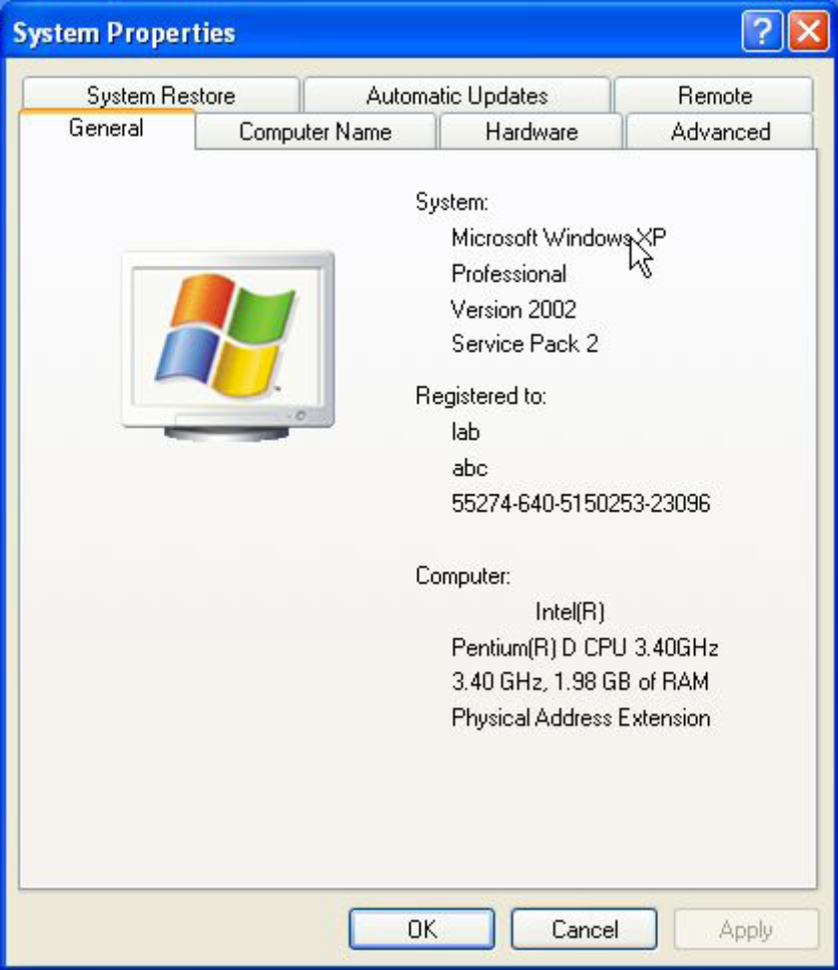
Click on the Device manager in the Hardware tab.
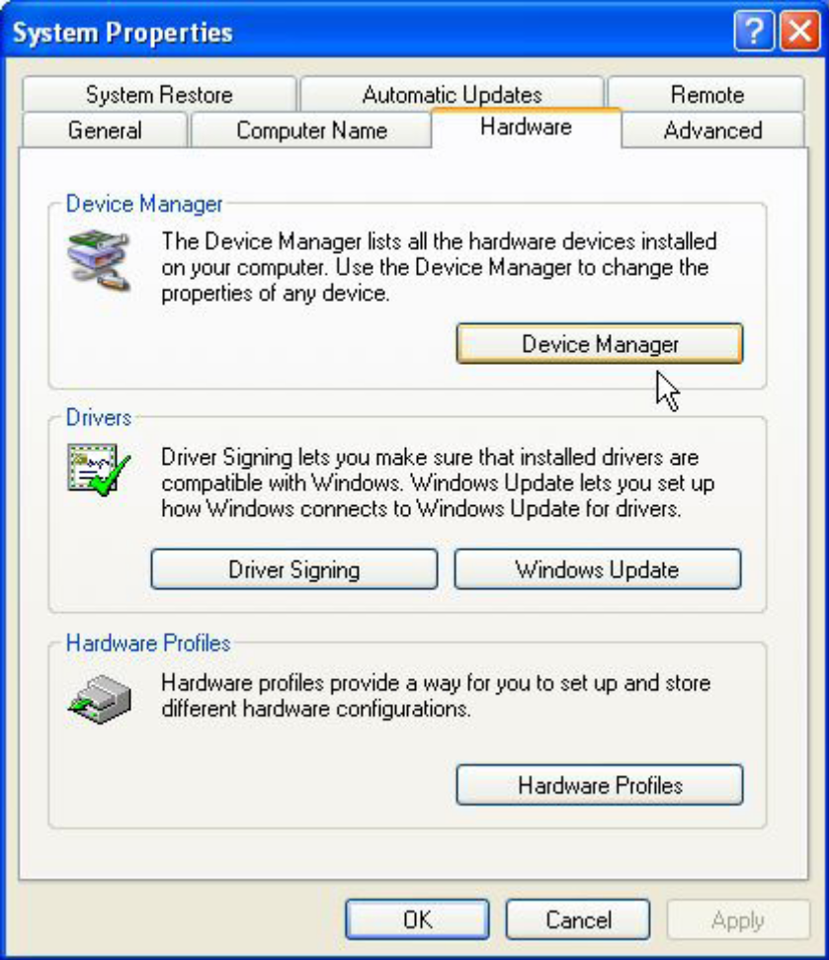
Step3
Expand Ports (Com & Lpt) tree. COM Port number is mentioned in the parenthesis next to USB Serial Port.
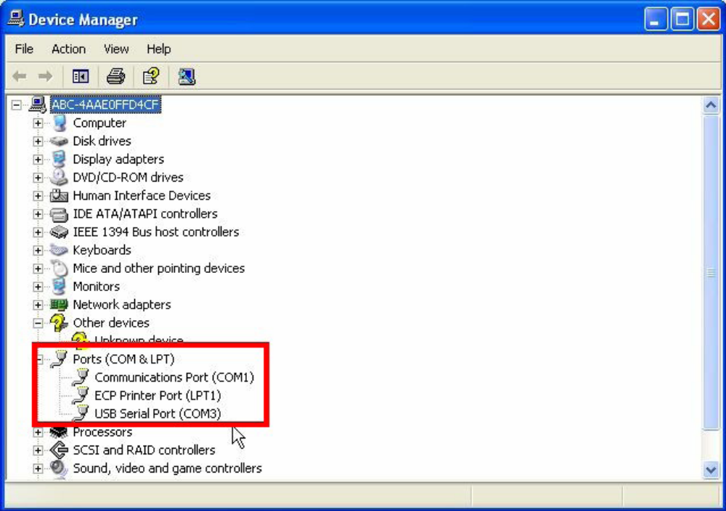
Troubleshooting Tip
If the COM port number is greater than “10” Terminal program included in the CD will not be able to detect it. To resolve this problem, change the port number by right clicking on “USB serial Port” and select properties.
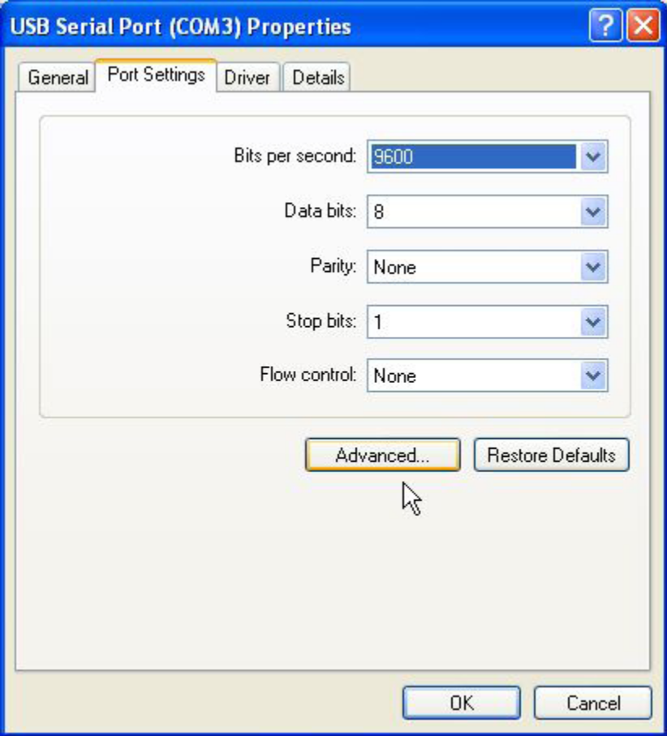
In the Port settings tab click on the Advanced button, the following window will appear.
